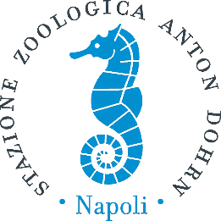

International Summer School
The Evolution of Enzymes and Metabolic Pathways in Marine Organisms
Registration form

First name Family name

Date of birth Fiscal Code

Personal address

City Cap Country

E-mail

Phone number

Current position: title, name of the institution, address, PhD school, if any.

Motivation to attend the school and basic knowledge (max 50 words)

Payment information
The registration fee of 150 EU (120 EU for early registration) includes participation to all school activities as well as lunches and coffee break on 14-16 July and social dinner.

We remind you that we will accept a maximum number of 25 participants, selected by the scientific commettee. The school will take place upon the participation of a minimum of 15 students.
Please send us this registration form and a copy of the wire transfer no later than April 15 th, 2020 at sspe1@szn.it. You will be notified by e-mail that your registration has been accepted.

Payment is possible by bank transfer at this bank account:

Stazione Zoologica di Napoli “Anton Dohrn” P. IVA 04894530635

Name of the bank: | Banca Nazionale del Lavoro
Branch adress
(street and nr.): | Piazza dei Martiri, 23/b
Post code: | 80121
Locality: | Napoli
Country: | Italy
Bank account holder: | Stazione Zoologica di Napoli
Bank account number: | 218010
Branch-code: | Code ABI: 01005
Agency code: | Code CAB: 03407
BIC code (Swift adress): | BNLIITRR
CIN code: | L
IBAN: | IT 87 L 0100503407000000218010

Payment reference : Registration for SSPE 2020/ name of the partecipant

Upon payment of the registration fee, SZN will issue a formal receipt.
Contact us at sspe1@szn.it for further information.

Date, Signature______________________

